RAG using LangGraph
The chat now has an additional feature that allows users to upload documents and work with their content.
Explanation:
- We can chat normally with the chatbot.
- We can use different types of tools:
  - Given/pre-built tools
  - Custom tools
  - MCP tools
- Additionally, we can upload documents and interact with or work with their content.

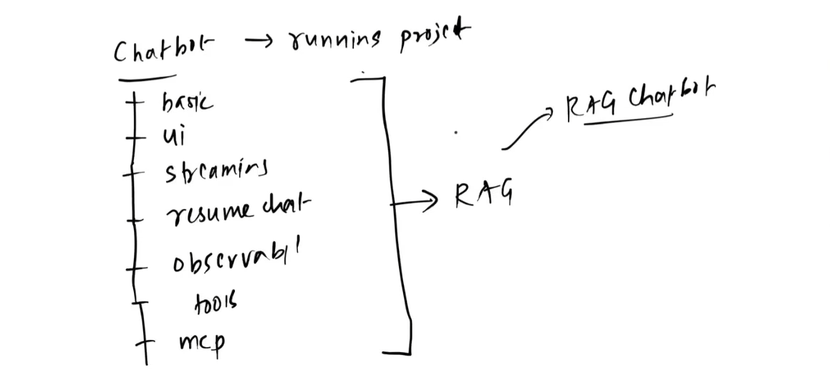
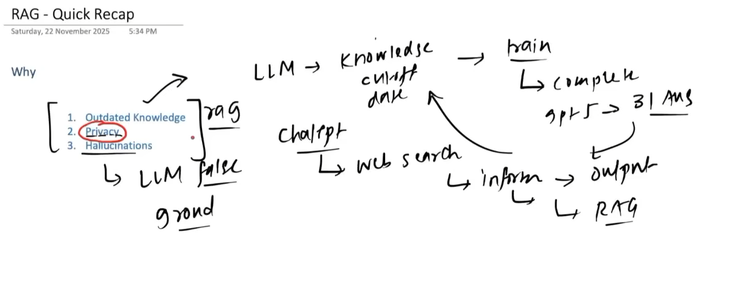

Each LLM has a limited context window, which restricts how much information can be provided to it in a single request.
Explanation:
- Since the context window is limited, we cannot provide the entire available context every time we ask the LLM something.
- Therefore, we try to filter the context and provide only the most relevant information needed for the current request.
- This helps us stay within the LLM's context limit while still giving it the information necessary to generate a useful response.
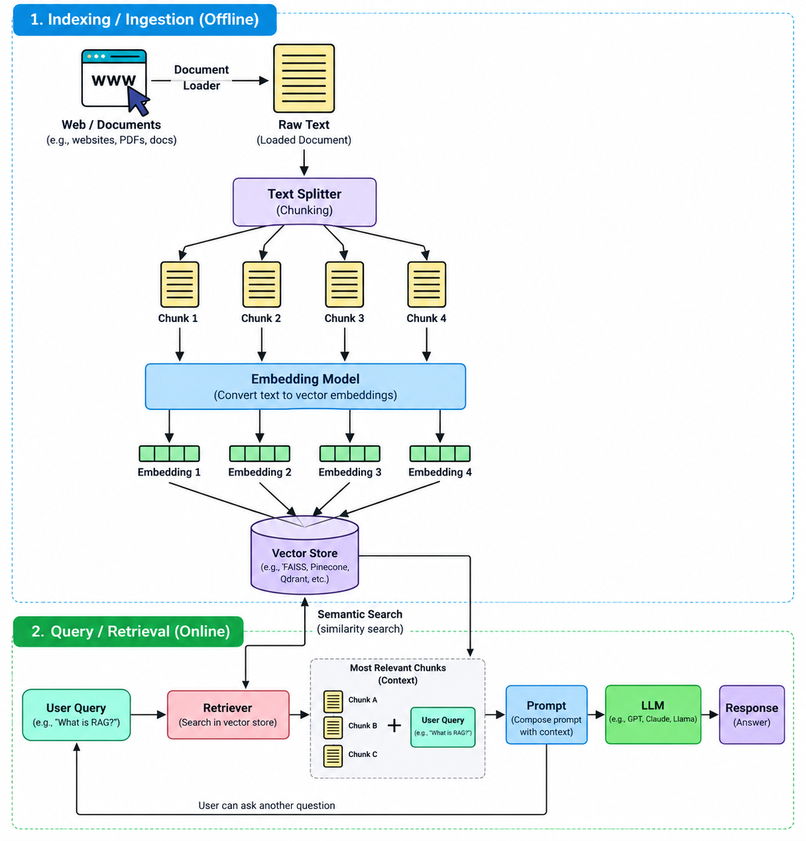
Definition:
An LLM uses the query, provided context, and its parametric knowledge to generate the best possible answer.
Explanation:
- Query: The user's question or instruction.
- Context: Relevant information provided to the LLM, such as conversation history or retrieved documents.
- Parametric knowledge: Knowledge learned and stored within the LLM's parameters during training.
- The LLM combines these sources to generate the answer
Here, we implement RAG (Retrieval-Augmented Generation) as a tool that an agent can call when it needs information from external documents or a knowledge base.
Explanation:
- Instead of making RAG the entire application pipeline, we expose the RAG system as a tool.
- The agent can decide when to use the RAG tool based on the user's query.
- This is a common way to integrate RAG into an agentic AI application, where the agent can combine RAG with other tools and capabilities.

Code:- I mean all of this standard. This loading .env and creating a model.
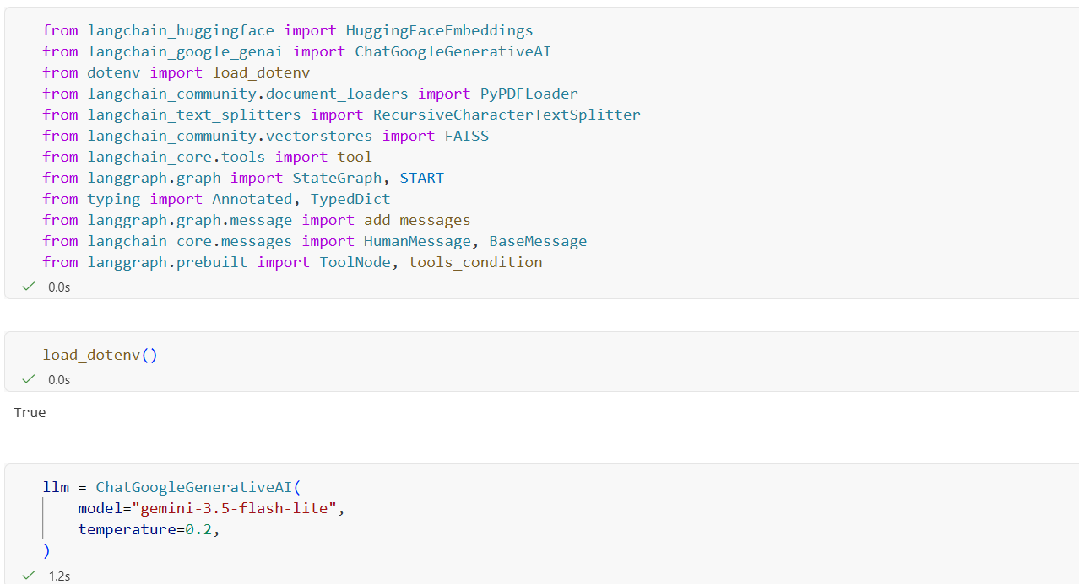
This is storing the pdf in doc and then splitting it and creating the embeddings of those chunks and then storing it in vector store called FAISS.
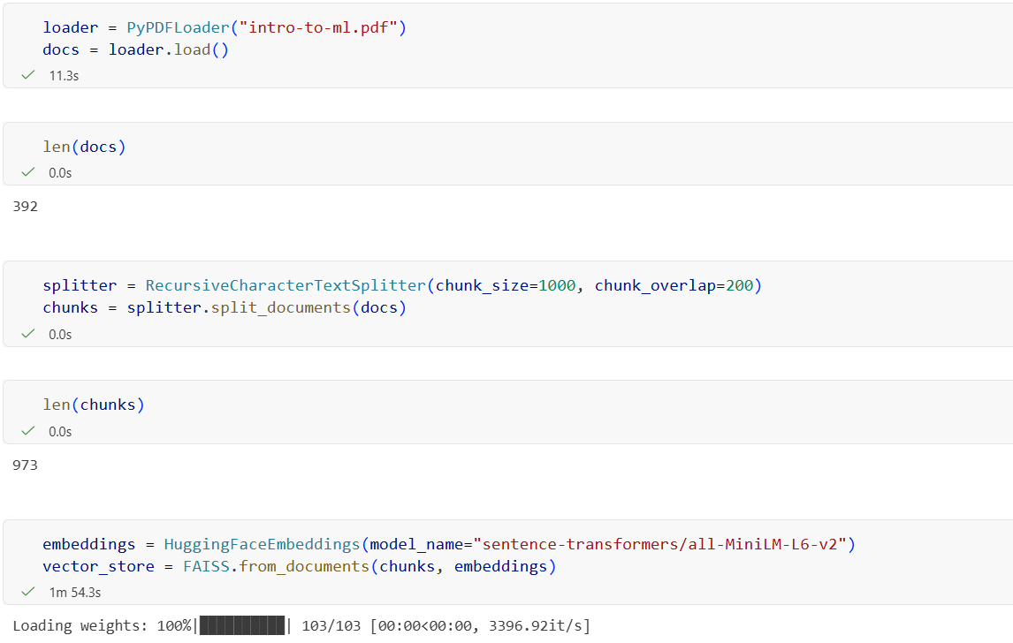
We create a retriever function, then create a tool for RAG. The RAG tool returns the query, context, and metadata.
Explanation:
- Create a retriever function.
- Create a RAG tool using the retriever.
- The RAG tool returns query, context, and metadata.
- Create llm_with_tools, an LLM that is aware of the available tools.
- Create the state.
- Create the chat_node and tool_node.
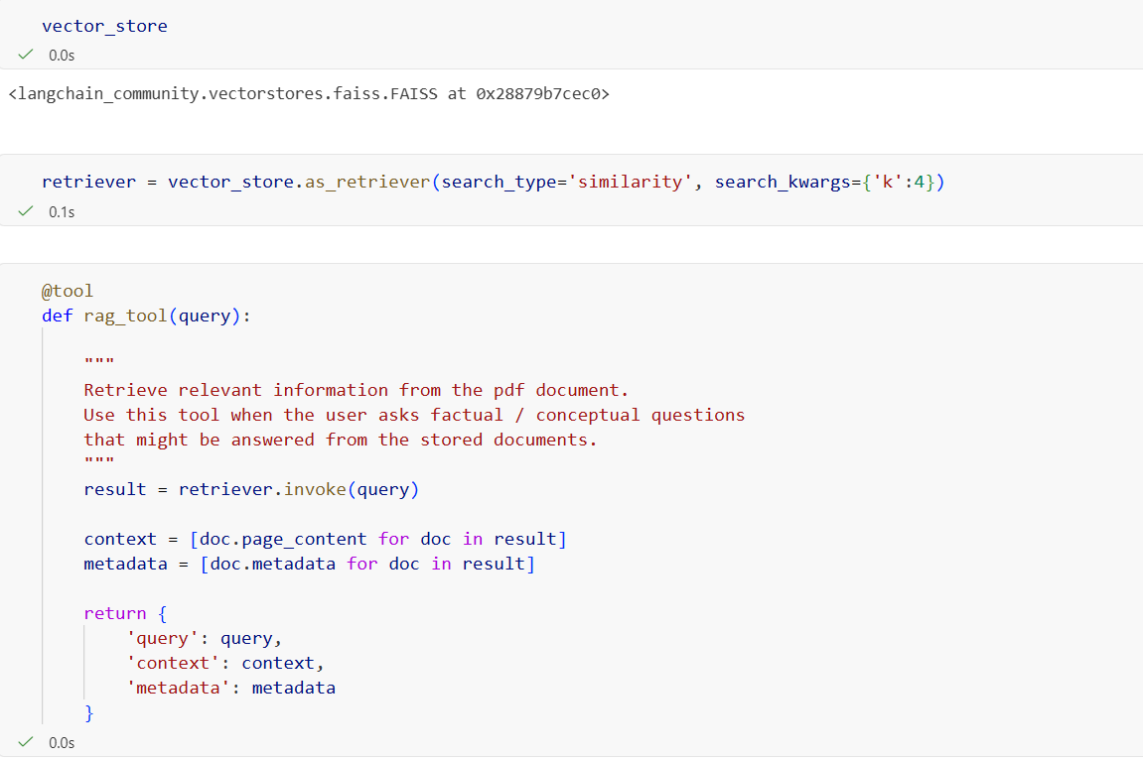
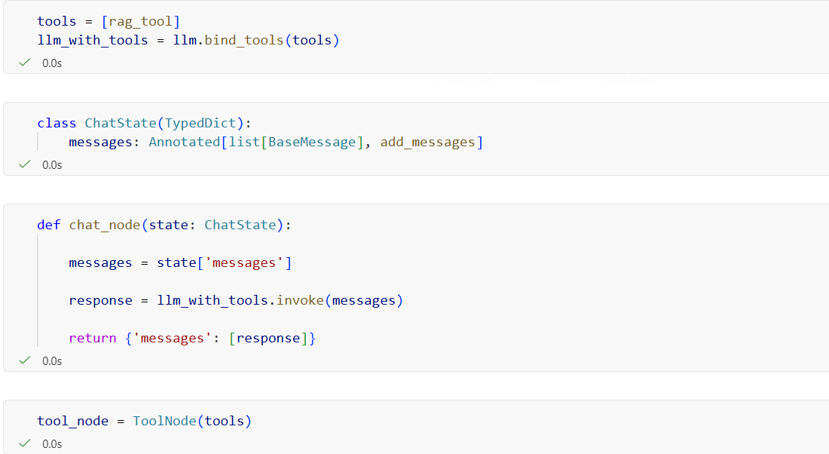
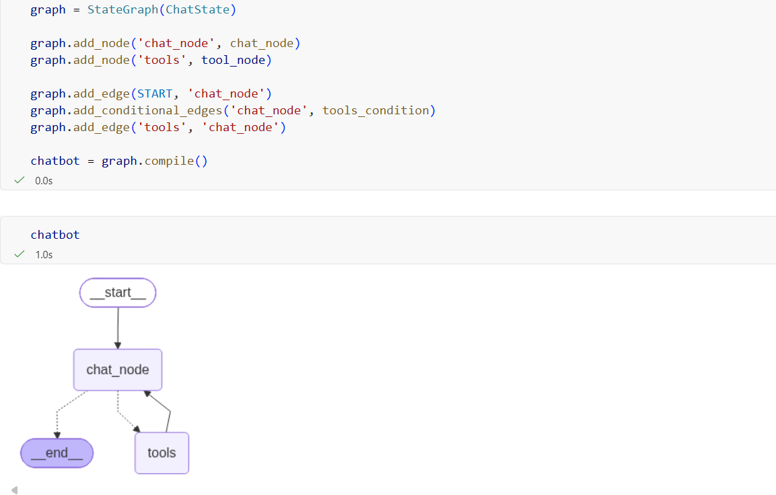
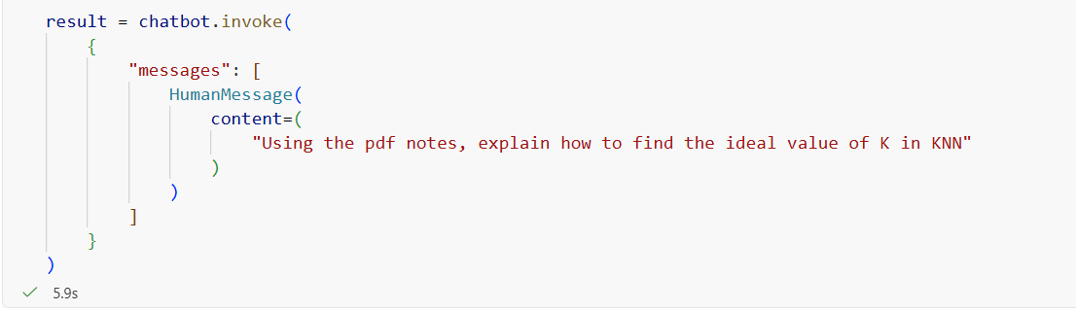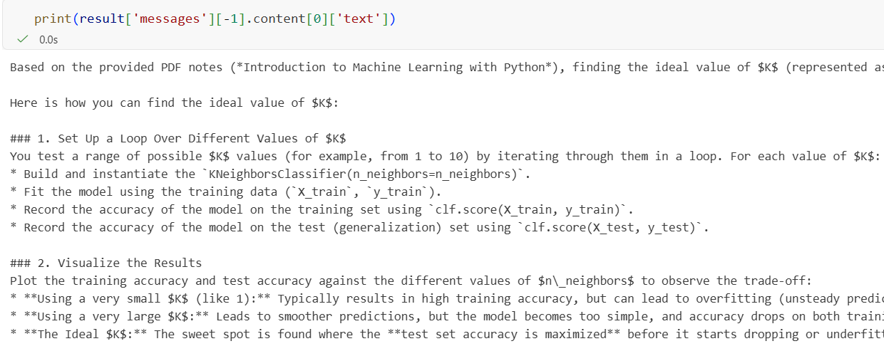
In langsmith :- This is how it looks in langsmith.
